Gothic Story
Assignment:
You will create your own Gothic tale. You must include at least four characteristics of Gothic literature in your story. Consider the following as you begin drafting -characters, setting, plot, dialogue, etc. The class will vote anonymously on the best tale. Winners will receive a prize!
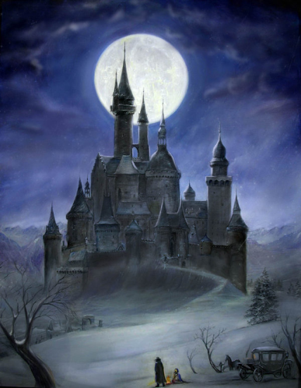
Requirements:
Your paper must include:
- Fully developed setting, background, and character(s)
- At least 4 elements of Gothic Literature
- Detail about character(s), events, setting(s), conflict, and resolution
Schedule:
- Monday (3/12):
  - Gothic Literature Notes
  - Gothic Story Assignment
  - Gothic Story: Pre-write
    - Due on Tuesday (3/13)
- Tuesday (3/13):
  - Gothic Story Pre-write due
  - Gothic Story: Outline
    - Due on Wednesday (3/14)
- Wednesday (3/14):
  - Gothic Story Outline due
  - Highlight and Label Gothic Requirements
  - Make final revisions to Gothic Story
    - Due on Thursday (3/15)
- Thursday (3/15):
  - Read Group Gothic Stories
    - Vote on best one (six finalists)
- Friday (3/16):
  - Top 6 Stories
    - Final winner is decided- Grand Prize

